**SPORTS MANAGEMENT SYSTEM**

**A Project Report**

Submitted in partial fulfilment of the

Requirements for the award of the degree of

**BACHELOR OF SCIENCE (INFORMATION TECHNOLOGY)**

**By**

Mansi Bhawar & Pallavi Futak

**Under the esteemed guidance of**

**Mrs. Prachi Yevlukr**

**Designation**



**DEPARTMENT OF INFORMATION TECHNOLOGY**

**N.G ACHARYA & D.K MARATHE COLLEGE**

(***Affiliated to University of Mumbai)***

**MUMBAI- 40061**

**MAHARASHTRA (2020-2021)**

### N.G ACHARYA & D.K MARATHE COLLEGE

### ***Mumbai University***

### **MUMBAI-(40061)**

**DEPARTMENT OF INFORMATION TECHNOLOGY**

### 

### **CERTIFICATE**

This is to certify that the project entitled, **"Sport Management System"**, is beanfield work of MANSI MANGESH BHAWAR bearing Seat No : 09 Summitted in partial fulfilment of the requirements for the award of degree of BACHELOR OF SCIENCE in INFORMATION

TECHNOLOGY from University of Mumbai.

Internal Guide Coordinator

**External Examiner**

**Date:**

### **PROFORMA FOR THE APPROVAL PROJECT PROPOSAL**

***(Note:All entries of the proforma of approval should be filled up with appropriate and complete information. Incomplete proforma of approval in any respect will be summarily rejected.)***

PNR **No.:** roll no**: __09_________**

1. Name of the Student: - Mansi Mangesh Bhawar

2.Title of the Project – Sport Management System.

3. Name of the Guide – Prachi yerpude

4. Teaching experience of the Guide

5. Is this your first submission? Yes No

Signature of the Student Signature of the Guide

Date: ………………… Date: …………………….

Signature of the Coordinator

Date: …………………

**ABSTRACT**

The[SportsManagementSystem](https://codeshoppy.com/shop/product/sports-management-system/)**(SMS)** objective is to provide which manages the activity of many sports at a time. It also manages the selection activity of students to college and to state level. The users will consume less amount of time when compared to manual paper work through the automated system. The system will take care of all the servicing activity in a quick manner.

Data storing is easier. It will be able to check any report at any time. Paper work and manual work is reduced. The system is user friendly and easy to use.

* Goal oriented
* Deliberately Structured
* Deliberately Coordinated
* Exist as a system of individuals and groups
* Made up of people with special skills

Sports Management System is a product to manage games/sports played at schools. This is an application that was developed to keep track of different sporting events with multiple games played between multiple schools and students.

**ACKNOWLEDGEMENT**

To list who all have helped me is difficult because they are so numerous and the depth .

I would like to acknowledge the following as being idealistic channels and fresh dimensions in the completion of this project.

I take this opportunity to thank the University of Mumbai for giving me chance to do this project.

I would like to thank my Principal, **DR. VIDYAGAURI LELE** for providing the necessary facilities required for completion of this project.

I take this opportunity to thank our Coordinator **AKILA MAHESHWARI**

, for her moral support and guidance.

I would also like to express my sincere gratitude towards my project guide

**Prof. Prachi Yerpude** whose guidance and care made the project successful.

I would like to thank my College Library, for having provided various reference books and magazines related to my project.

Lastly, I would like to thank each and every person who directly or indirectly helped me in the completion of the project especially

My Parents and Peers who supported me throughout my project

### **DECLARATION**

I hereby declare that the project entitled, “**Sport Management System**” done at **place where the project is done**, has not been in any case duplicated to submit to any other university for the award of any degree. To the best of my knowledge other than me, no one has submitted to any other university.

The project is done in partial fulfilment of the requirements for the award of degree of ***BACHELOR OF SCIENCE (INFORMATION TECHNOLOGY)*** *to be submitted as final semester project as part of our curriculum.*

Name and Signature of the Student

**TABLE OF CONTENT**

Chapter 1: Introduction

1.1 introduction of project

1.2 objective

1.3 scope

1.4 purpose

1.5 background

1.6 organization of project

Chapter 2: Survey of technology

Chapter 3: Requirement and analysis

3.1 problem definition

3.2 Requirement specification

3.3 Software and hardware requirement

3.4 Conceptual model

3.5 Feasibility study

Chapter 4: System Design

4.1 Basic modules

4.2 schema design

4.3 Integrity constraints

4.4 ERD Diagrams

4.5 Context level DFD

4.6 DFD

4.6.1 First level DFD

4.6.2 Second level DFD

4.6.3 Third level DFD

4.6.4 Fourth level DFD

4.7 Security

**1.INTRODUCTION**

1.**1 Introduction of project**

Sports Management system is the system which takes care of all the

activities related to Sports and sports events. In this system we are

maintaining the data of all transaction which related to managing

sports matches.

In this system maintaining the data of all Teams and corresponding his

players. Also managing the assigning matches and his schedules, price

distribution. Also generating all reports like Match schedules, Winner Details

**1.2 Scope**

Various Sports types

➢ Team Registration Details

➢ Match Scheduling & assigning the matches into the team

➢ Price Scheduling Details

➢ Result Declaration & assigning the price

➢ Generating the Reports like Match schedules, Winner Details etc.

**1.3 Objective**

The objectives to be fulfilled by this system are:

1. Proposed system should be faster, more secure and simpler.

2. Proposed system should provide sports details

3. Proposed system should reduce the workload and time.

4. System should have simple and user-friendly interface

**1.4 Purpose**

The purpose of sport management system is student can get all the information of various games and the venue. The student can get registered from anywhere and at any time .by using this system student can save a lot of time and effort. The student can easily get the information from anywhere.

**1.5 Background**

The Sport management system is a portal that manages the overall activities of sports in a particular institution.it includes the management of various equipment, teams, tournaments and various other events conducted by the sport committee

**1.6 Organization of Report**

Games: cricket, football, kabaddi, running races, carrom, chess.

Schedule: match Schedule can be done automatically or manually

Prize distribution: you will be notified.

**2.SURVEY OF TECHNOLOGY**

**2.1 ASP**

It is an integrated development environment from Microsoft. It is used to develop

computer programs for Microsoft Windows, as well as web sites, web application and web

services. Visual Studio uses Microsoft software development platforms such as Windows API,

Windows Forms, Windows Presentation Foundation, Windows Store and Microsoft Silverlight.

It can produce both native code and managed code.

Visual studio includes a code editor supporting intelligence as well as code refactoring.

The integrated debugger. Other built-in tools include for designer for building GUI application,

web designer, class designer, and database schema designer. It accepts plug-in that enhance the

functionality at almost every level-including adding support for source-control system and

adding new tool set like editor and visual designer for domain-specific languages or tool set for

aspect of the software development life cycle.

Visual studio support different programming languages and allows the code editor

debugger to support nearly any programming languages, provide languages-specific service

exist.

**2.2 SQL Server**

Microsoft SQL server is a relational Database Management System developed by

Microsoft. As a database, it is a software product whose primary function is to store and

retrieve data as requested by other software application, be it those on the same computer or

those running on another computer across a network. There are at least a dozen different

additions of Microsoft SQL server aimed at different audiences and for work load ranging from

small single-machine application to large internet-facing application with any current user.

**3.REQUIREMENT AND ANALYSIS**

**3.1 Problem definition**

The **Sports Management System** (SMS) **aims** to provide which manages the activity of many **sports** at a time.

**3.2Requirement Specification**

These requirements have been taken into due consideration while preparing the system right from the scope of the project to the proposed system and the system design.

These requirements have already been taken into consideration while discussing the proposed system and objectives to be fulfilled as mentioned above and will not be repeated again in order to avoid data redundancy.

**3.3 Software Requirement**

Front End: VB.Net

Back End: MS Access

**3.4 Hardware Requirements:**

Ram: 128 MB or above

Hard Disk: 3 GB or above

O.S.: Windows 2007, xp professional

Processor: Intel Pentium 4 1.6 GHz

Monitor: LG

**3.5 CONCEPTUAL MODEL**

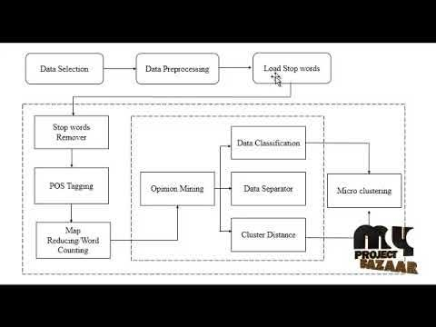

**3.6 Feasibility Study**

Performing the preliminary investigation tells us whether the system we are going to be developing is practical or not. The feasibility study is the deciding factor for this. Feasibility study is a very important stage in the system development life cycle. It helps us to obtain an overview of the problem and to acquire a rough assessment of whether feasible solutions for problems that may occur exist or not.

It can define problems, objectives involved in the project. With feasibility study we can avoid costly repairs at the later stage.

Feasibility study can be carried out in the following areas:

1). Technical feasibility

2). Economical feasibility

3). Operational feasibility

### **TECHNICAL FEASIBILITY**

The assessment is based on an outline design of system requirements in terms of input, processes, output, fields, programs, and procedures. This can be quantified in terms of volumes of data, trends, frequency of updating, etc.in order to estimate whether the new system will perform adequately or not.

### **ECONOMIC FEASIBILITY**

### 

Economic analysis is the most frequently used method for evaluating the effectiveness of a new system. More commonly known as cost/benefit analysis the procedure is to determine the benefits and savings that are expected from a candidate system and compare them with costs. If benefits out weight cost, then the decision is made to design and implement the system.

### **OPERATIONAL FEASIBILITY**

It a measure of how well a proposed system solves the problem, and takes advantages of the opportunities identified during scope definition and how it satisfies the requirements identified in the requirements analysis phase of system development.

**4. SYSTEM DESIGN**

**4.1 Basic Modules**

* Login Registration: Admin provides username and password to the employee. He also has the right to add or modify the given username and password of the employee. Using this username and password, an employee can login to the system.
* Student Registration: The first procedure is the student registration. Here the employee enters all the details of a student including the sport they like to participate. All this information will be stored in the database.
* Tournament: Here depending on the sport, the tournament date and the venue is saved in the database for further confirmation.
* Games: . A list of players will be displayed and also the upcoming tournaments will be shown according to the particular sport. The system also provides a special authority of adding photos to the system for a particular sport for sweet memories and for proof.
* Selection procedure: The system also does the selection procedure to the college level and the state level competition. To the college level all the players are allowed to play. Whereas to the state level, the best players will be selected from the college level list which will be also saved in the database.
* Logout: This module allows the user to Logout the application. Further operations cannot be performed after user exits

**4.2 schema design**

Database schema design is a strategy for constructing a framework for data management. Just like in architecture, a solid database needs to have a blueprint to keep the project on track.

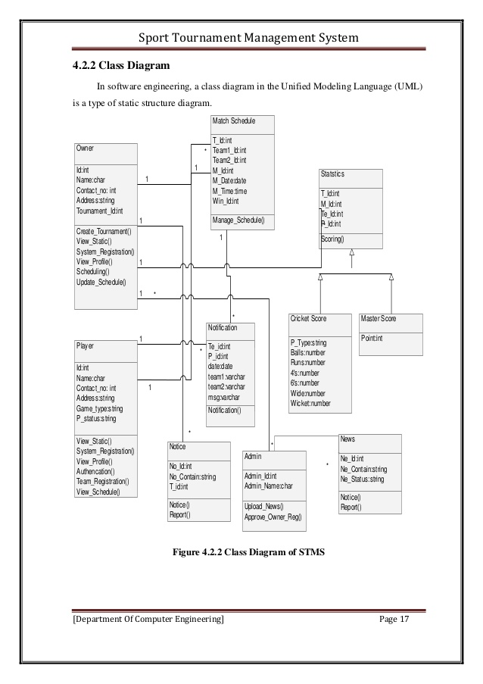

# **4.3 Integrity Constraints**

* Integrity constraints are a set of rules. It is used to maintain the quality of information.
* Integrity constraints ensure that the data insertion, updating, and other processes have to be performed in such a way that data integrity is not affected.
* Thus, integrity constraint is used to guard against accidental damage to the database.

## **Types of Integrity Constraint**

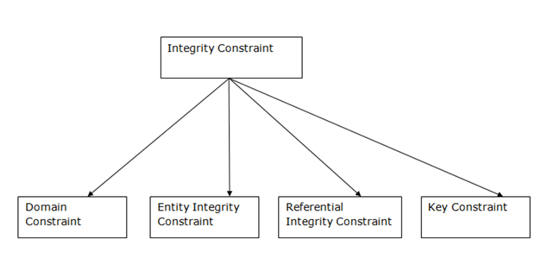

**4.4 ERD DIAGRAM**

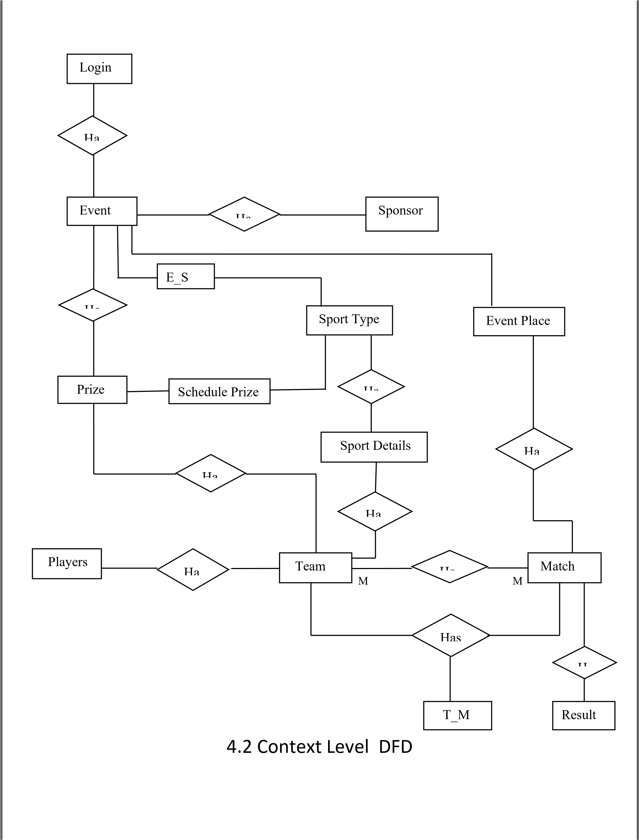

4.5 CONTEXT LEVEL DFD

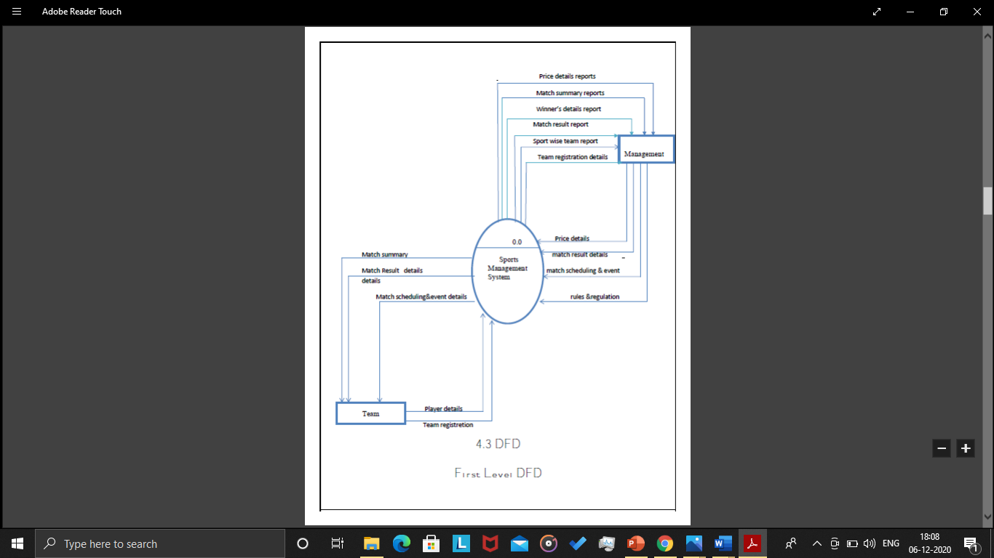

**4.6 DFD**

4.6.1 First Level DFD

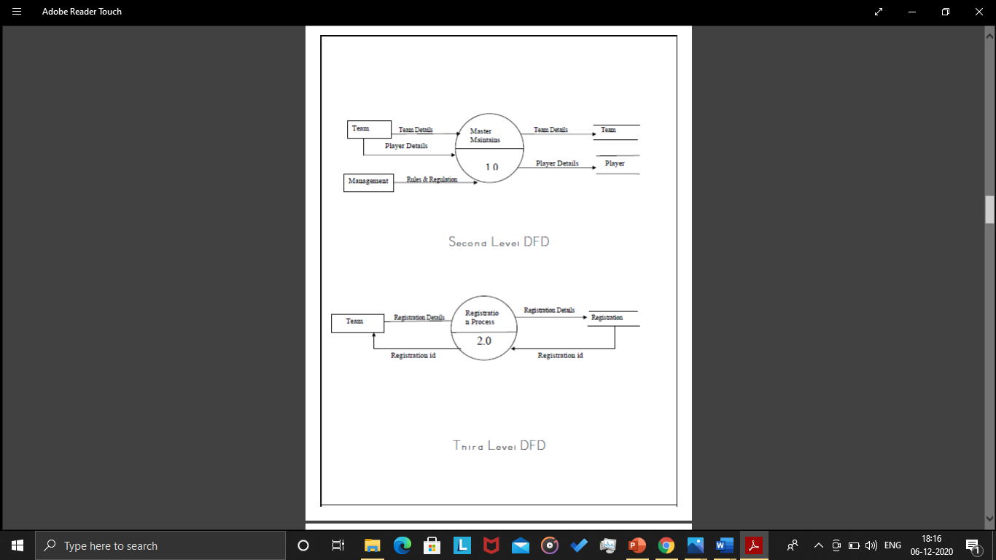

4.6.2 Second Level DFD

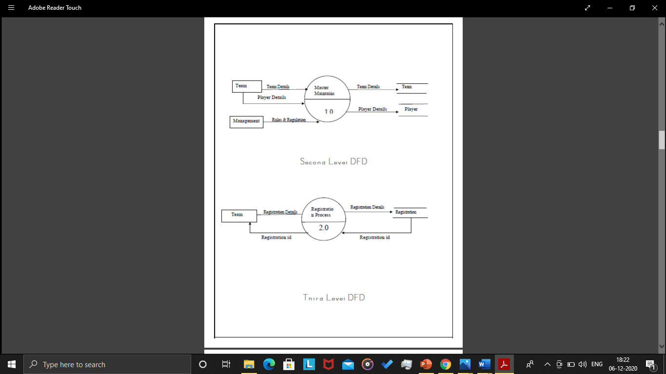

4.6.3 Third level DFD

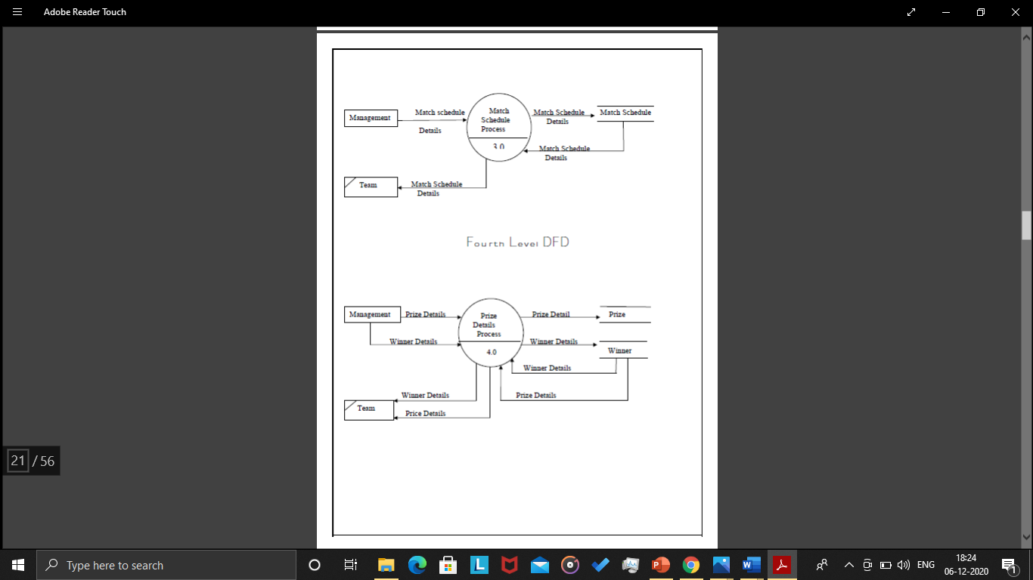

4.6.4 Fourth Level DFD



4.7 TABLE DESIGN

Admin Login Table: -

|  |  |  |
| --- | --- | --- |
| Field Name | Data Type | Constraints |
| Id | AutoNumber | Primary Key |

|  |  |  |
| --- | --- | --- |
| uname | text |  |
| password | text |  |

Event Table: -

|  |  |  |
| --- | --- | --- |
| Field Name | Data Type | Constraints |
| e_Id | AutoNumber | Primary Key |
| event name | text |  |
| event place | text |  |
| start date | Date/Time |  |
| end date | Date/time |  |
| Created Date | Date/Time |  |

Event Place Table: -

|  |  |  |
| --- | --- | --- |
| Field Name | Data Type | Constraints |
| ep_id | AutoNumber | Primary Key |
| ep_name | text |  |
| Address | text |  |
| ep_phone_no | Number |  |
| contact_person_name | text |  |
| mobile_no | Number |  |
| email_id | text |  |
| Created_Date | Date/Time |  |

Match Schedule Table: -

|  |  |  |
| --- | --- | --- |
| Field Name | Data Type | Constraints |
| schedule_id | AutoNumber | Primary Key |
| e_Id | Number | Forgin Key |
| sport_name | text |  |
| team1_name | text |  |
| team2_name | text |  |
| sports date | Date/Time |  |
| sports time | Date/Time |  |
| Created_Date | Date/Time |  |

Player Table: -

|  |  |  |
| --- | --- | --- |
| Field Name | Data Type | Constraints |
| p_Id | AutoNumber | Primary key |
| t_Id | number | Forgin Key |
| Last-named | text |  |
| First name | text |  |
|  |  |  |

Price distribute Table

|  |  |  |
| --- | --- | --- |
| Field Name | Data Type | Constraints |
| pd_id | AutoNumber | Primary key |
| event name | text |  |
| winner team | text |  |
| price name | text |  |
| Created_Date | Date/time |  |

Price schedule Table

|  |  |  |
| --- | --- | --- |
| Field Name | Data Type | Constraints |
| ps_id | AutoNumber | Primary key |
| e_Id | Number | Forgin Key |
| id | Number |  |
| price_id | Number |  |
| price amount | Number |  |
| trophy | text |  |
| Created_Date | Date/time |  |

Price Type Table

|  |  |  |
| --- | --- | --- |
| Field Name | Data Type | Constraints |
| price_id | AutoNumber | Primary key |
| id | Number | Forgin Key |
| price_type | Text |  |
| description | Text |  |
| Created_Date | Date/Time |  |

Result Table

|  |  |  |
| --- | --- | --- |
| Field Name | Created_Date | Constraints |
| result_id | AutoNumber | Primary key |
| schedule_id | Number | Forgin Key |
| winner team | Text |  |
| Created_Date | Date/Time |  |
|  | | | |  |  |
|  | | | |  |  |
|  | | | |  |  |
| Sponsor Table   |  |  |  | | --- | --- | --- | | Field Name | Data Type | Constraints | | S_Id | AutoNumber | Primary key | | Sponser_Name | Number |  | | Address | Text |  | | Phone Number | Number |  | | E_Id | Number |  | | Created_Date | Date/Time |  |     Sport Details Table   |  |  |  | | --- | --- | --- | | Field Name | Data Type | Constraints | | sd_id | AutoNumber | Primary key | | id | Number | Forgin Key | | total_player | Text |  | | playing player | Text |  | | Created_Date | Date/Time |  | | | | |  |  |

Sport Type Table

|  |  |  |
| --- | --- | --- |
| Field Name | Data Type | Constraints |
| id | AutoNumber | Primary key |
| sport_name | Text |  |
| sport type | Text |  |
| description | Text |  |
| Created_Date | Date/Time |  |

Team Table

|  |  |  |
| --- | --- | --- |
| Field Name | Data Type | Constraints |
| t_Id | AutoNumber | Primary key |
| id | Number | Forgin Key |
| team name | Text |  |
| team_address | Text |  |
| mobile_no | Number |  |
| email_id | Text |  |
| Created_Date | Date/Time |  |
|  |  |  |

Team Wise Event Table

|  |  |  |
| --- | --- | --- |
| Field Name | Data Type | Constraints |
| tw_id | AutoNumber | Primary key |
| e_Id | Number | Forgin Key |
| sport_name | Text |  |
| team name | Text |  |
| Created_Date | Date/Time |  |

**4.7 SECURITY**

As the user has to provide valid username and password before login on, the system remains secure from unauthorized access.